Capstone Project Plan
Project Concept:
Create a Skill Tracking and Learning Website. The idea is to create a hub for individuals to help with tracking the level of skill mastery you have obtained. The site will contain training links for professional development and resources like the documentation for applications like Python, REACT or Microsoft.

Project Overview:
- Home Page
  - To display links for the sub-sites.
  - Allow users to create accounts.
- Skill Dashboard
  - Add/Edit/Delete Skills with proficiency levels.
  - Visual Progress bar or chart
  - Categorize skills (Frontend, Backend, DevOps, Soft Skills)
  - Track changes (Added or last updated)
- Job Board Integration
  - Link to API’s like Indeed, LinkedIn, GitHub Jobs
  - Search jobs by keywords, location or keyword.
  - Display relevant jobs based on tracked skills.
  - Save/Bookmark interesting listings
  - View relevant details for the position.
- Learning Resource Library
  - Links to tutorials, courses, documentation.
  - Tag resources by skill area.
  - Mark resources with progress. (Complete, In Progress, planned)
  - Add Personal notes to each resource
Screen Capture Concepts:
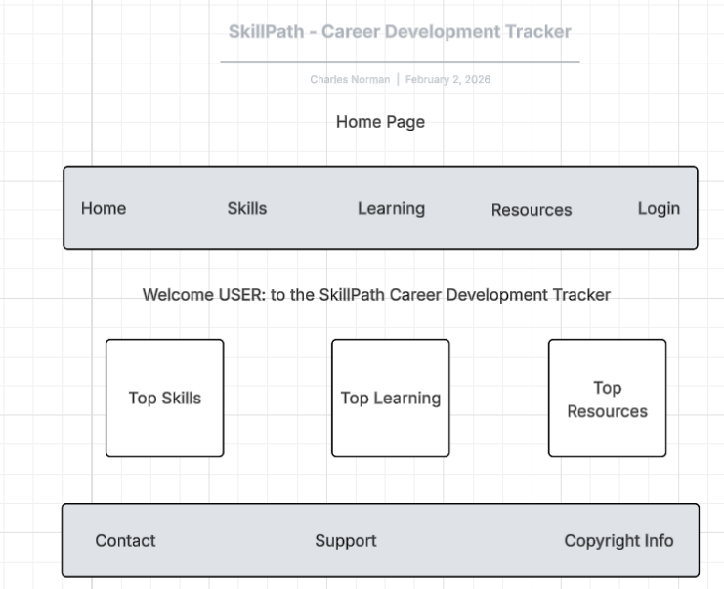
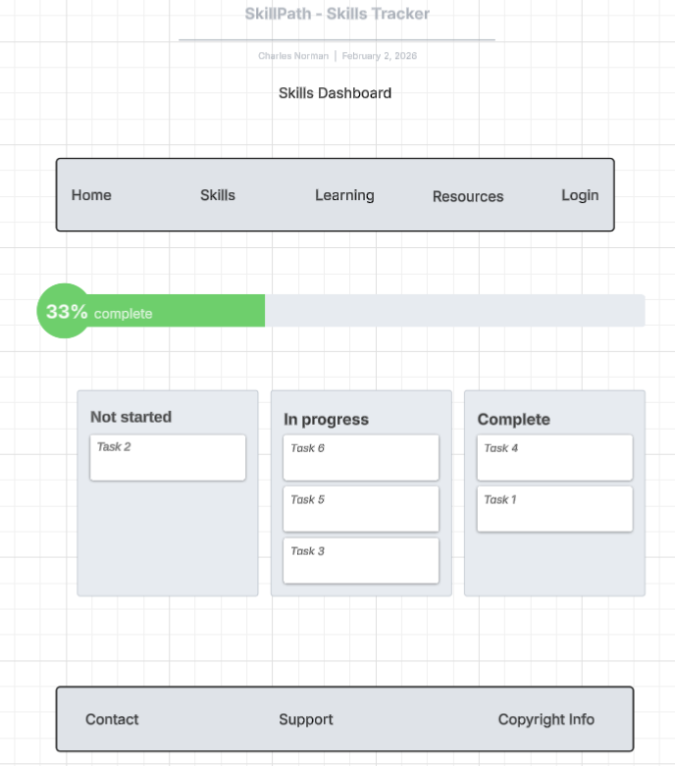

Skills Page
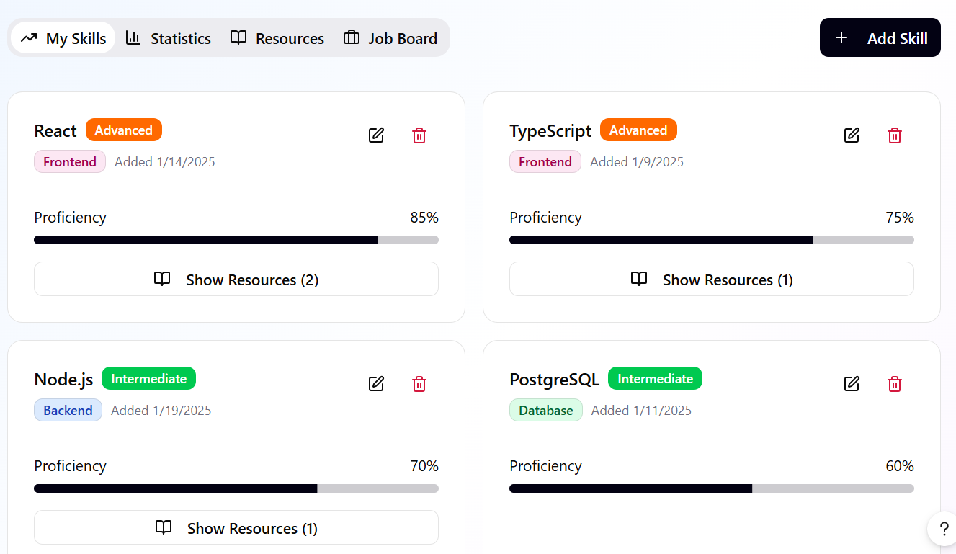

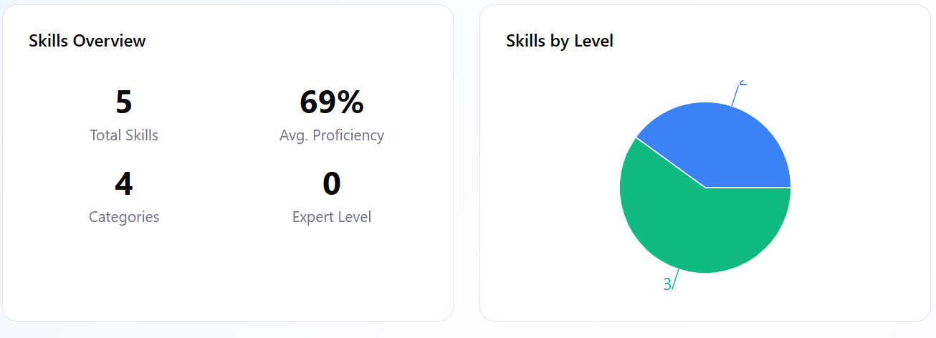
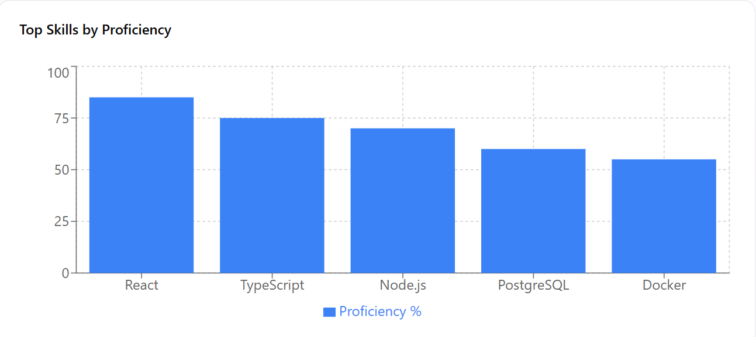
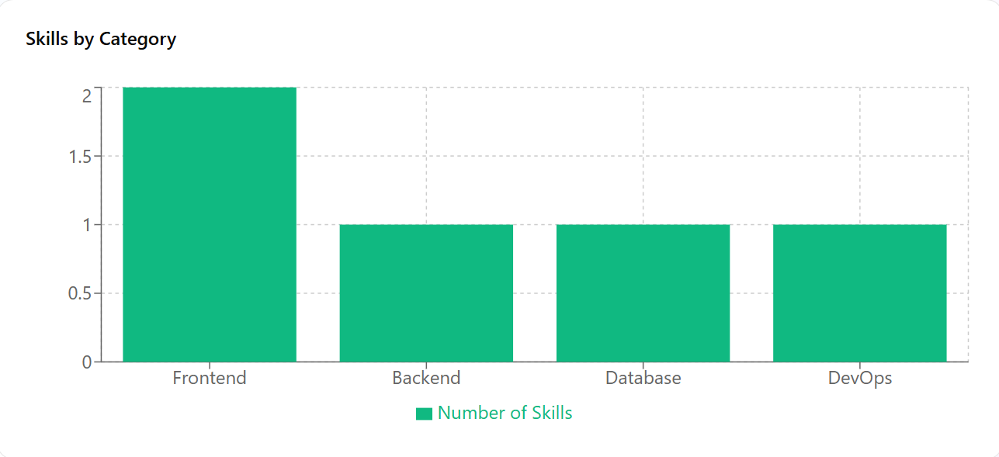

Resources Page
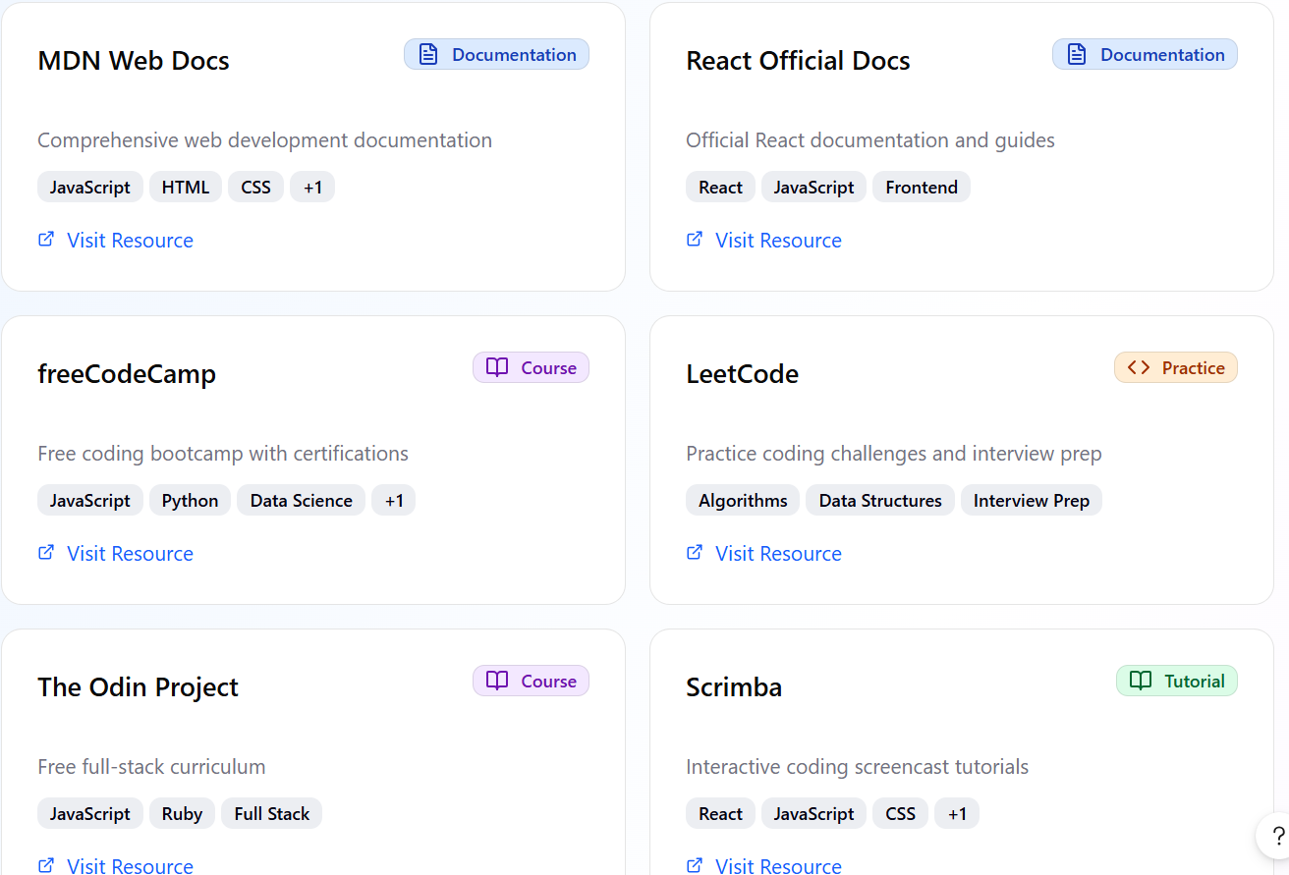

Job Search Page
